Newport Cricket Club Win 2010, U13 National Championships.
Newport Cricket Club won the prestigious ECB U13 UK National Championship, being the only unbeaten team in five matches against some of the best junior club teams in the country at Oakham School last week. The amazing win rekindled memories of the Club’s previous UK success in 2005.
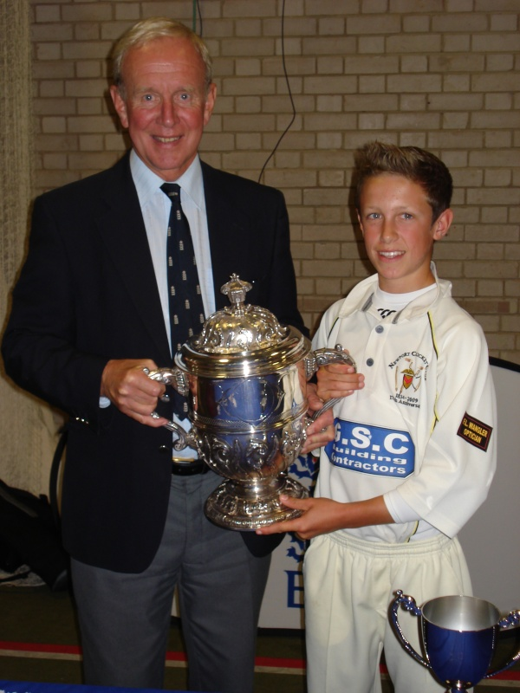
Captain Matt Jones, Receives the ‘Ken Barrington Trophy’ from England Legend, Derek Underwood
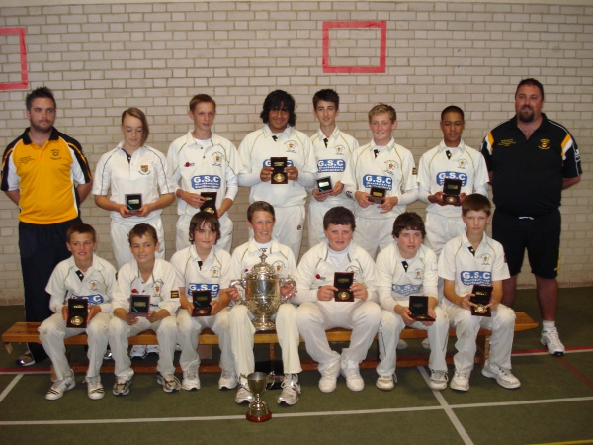
Newport U13's - 2010 UK National Champions

U13 UK National Finals 2010
Over 1800 teams entered the 'Spirit of Cricket' U/13 Club Championship, with 27,000 Junior cricketers hoping to lift the trophy, but it was Newport who gallantly came out on top.
Newport Cricket Club were one of six finalists in the U/13 U.K National Finals held in a week long festival at Oakham Public School, in Rutland, Leicestershire. It had been a long trek for the young Newport team.
Having previously won the Welsh Cup, with a victory in the final against Pontardulias, they booked their place at Oakham by beating the Gloucestershire / Somerset Champions, Bristol CC, followed by victory in the South West of England, & Wales Regional Finals, at Weston Super-Mare, where they beat opposition from Poulton (Gloucstershire), Swindon (Wiltshire) and Exeter (Devon):-

The 6 Regional Winners:-
West of England Champions - Newport CC (Wales)
North of England Champions – Old Leodiensian CC (Yorkshire)
North West Champions - Lindum CC (Lincolnshire)
Midlands Champions – Old Elizabethans CC (Worcestershire)
South and South East Champions - Ealing CC (Middlesex)
East of England Champions - Spencer CC (Surrey)
The format of the week was to play 20 over matches against the other five Regional Champions. Two games a day, the competition winners to be decided on a League basis.

Day 1 (August 11th)
Newport v Spencer
Newport set the standard in their first game as they beat Spencer in extremely convincing style. Newport batted first and posted a very challenging 156 for six.
Spencer in reply were never able to keep up with the rate and were bowled out for 82.Taking advantage of the good early conditions, Newport began well and were 55 for two after 10 overs, thanks to solid innings from Jack Thorpe-Yon (27) and Nathan Hariharan (30 No). In the second half of the innings Newport accelerated thanks to some big hitting from Dan Lezar and Rob Williams, scoring at a rate of 10 runs per over and setting a formidable target.
In reply, Spencer made a good start with Boys-Stones contributing 29 and were up with the run rate after five overs. However, Newport quickly gained the
upper hand with the entrance of star leg-spinner and captain Matt Jones. He finished with figures of 4-12 from his four overs and was unlucky not to get a five wicket haul. Ably supported by the pace of Thorpe-Yon and Luke Harris, Spencer were bowled out in the 15th over for 82. This comprehensive victory
left Newport as one of the early favourites for the title.
Newport v Old Leodiensians
In second game of the day Newport posted their second win of the day, beating Old Leodiensians by five wickets. Batting first, and after a quick start,
aided by some good pinch-hitting by R Studholme, Old Leo’s were tied down by Newport’s three pronged attack of Nathan Hariharan, Matt Jones and Jack Thorpe-Yon. The pick of these bowlers was Thorpe-Yon with four overs 2-8.
This enabled Newport to restrict the opposition to a score of 74. Chasing an easily reachable total, Newport cruised to 32 before the big-hitting
Nathan Hariharan was run out for 15. Some nervy batting followed, but the target was easily reached after 17 overs thanks to an assured captain’s
innings of an unbeaten 30 by Jones.
At the end of the first day Newport looked good as title contenders, the only other unbeaten team being Ealing CC, who themselves had beaten Lindum and Spencer.
Day Two (August 12th )
Unfortunately Day Two was disrupted by rain as bad weather hit the region.
Newport v Lindum
The day started with fine rain and a delayed start. The matches were reduced to 15 overs a side. Newport played Lindum and batting first scored a
useful 97-3. Lindum in reply were 56-2 off 8.2 overs before heavy rain set in and the game had to be abandoned with no result, as a minimum of
10 overs were needed in the second innings to constitute a game
However, good news for Newport came when it was announced that one match had progressed far enough in the second innings to reach the 10 over mark which constituted a match. In this game Old Elizabethans had scored 79 for nine in their 15 overs and Ealing were 47 for three in reply after 10 overs. This meant that Old Elizabethans had won on run rate. A result which gave Newport a huge boost.
The morning matches between the other four teams were 'no results' with each team gaining 5 points.
Newport v Ealing
After lunch Newport were due to play Ealing in what looked like a title decider, but repeated attempts to restart the matches were thwarted by the
weather as more heavy showers ensued. Eventually torrential rain at 4pm caused the day's play to be abandoned.
All three matches in Round 4 were abandoned without a ball being bowled.
With 10 points for a win, Newport were looking in a commanding position at the top of the league at the end of day 2 with 30 points, closely followed by Ealing on 25 pts and Old Elizabethans on 20pts.

Day Three (August 13th )
On the final day Newport needed to beat Old Elizabethans in their final game to maintain their position on top of the six-team round robin table, but bad weather was again about to play its part.
With their opponents, Old Elizabethans tied down on 23 without loss in the seventh over rain first forced play to halt.
A half hour wait saw numerous showers pass before the umpires got the matches under way again; but only a few balls more were bowled
before a torrential and prolonged downpour put paid to any hope of further play on the day, with none of the games having even got through
half of the first innings.
That meant disappointment to challengers Ealing, who were playing Old Leodiensians and hoping for a Newport slip-up.
Newport skipper Matt Jones was presented with the Ken Barrington Trophy for the National U13 Champions by Ann Barrington, widow of former Test Star Ken, as the celebrations started for the 2010 winners, who like their 2005 predecessors had remained unbeaten throughout the Finals Festival.
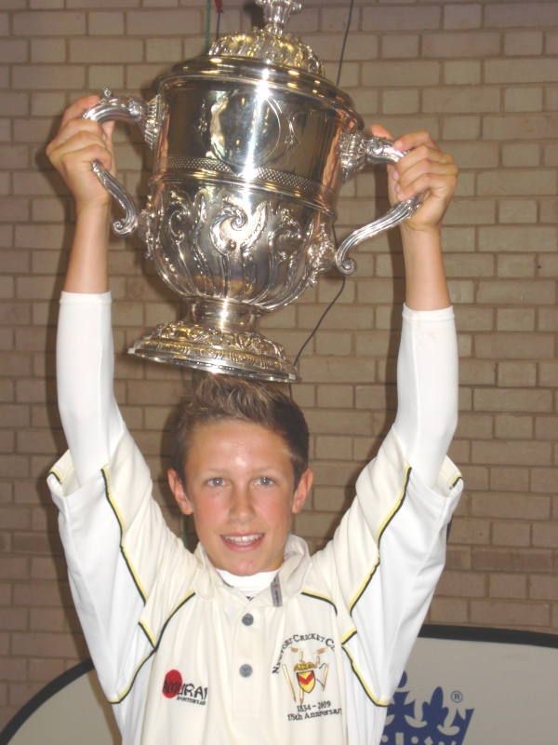
Matt with the 'Ken Barrington' Trophy
Newport coach Paul Morris told ecb.co.uk afterwards: "To be honest it's been one of the best experiences of my life. I can cast my mind back to May when we started out on a wet and windy night - and who'd have thought that now we'd be National Champions.
"It just reflects the way that we do things at Newport. We've got a great youth structure, and it's come to this where we've won the National Competition twice in 5 years. It's been great for the club, and I just hope it continues."
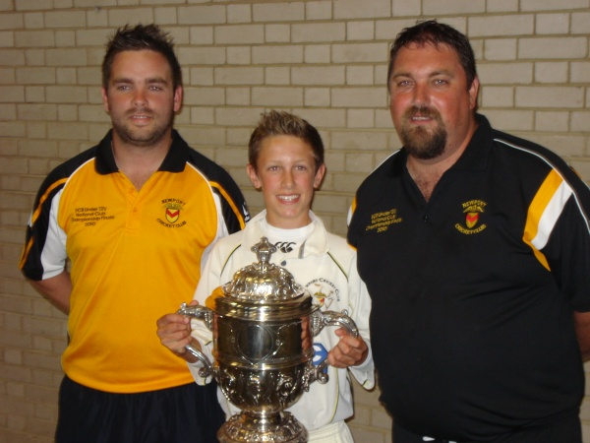
Captain, Matt Jones with Coaches, Nathan Millichip and Paul Morris
Final League Table
 | Played | Won | Tied | Lost | Abandoned | Points
Newport | 5 | 2 | 0 | 0 | 3 | 35
Ealing | 5 | 2 | 0 | 1 | 2 | 30
Old Eizabethans | 5 | 1 | 1 | 1 | 2 | 25
Old Leodiensians | 5 | 1 | 0 | 1 | 3 | 25
Spencer | 5 | 0 | 1 | 1 | 3 | 20
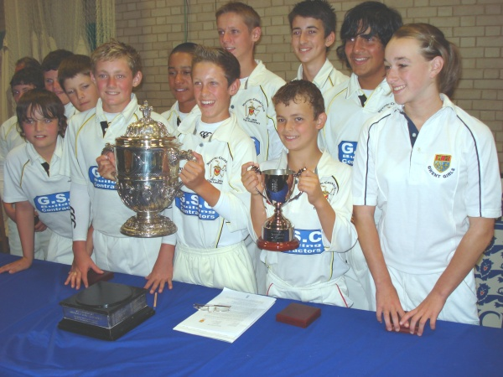
The Victorious Newport U13 Team - UK National Champions 2010
Giles Clarke, ECB chairman, said: “England stars such as Andrew Flintoff, Monty Panesar, and James Anderson have all taken part in the ECB U13 National Club Championship as have former England players such as Nasser Hussain, Steve Harmison and Marcus Trescothick.
“I think that shows the importance of the competition on the path from the playground to the Test arena and why it has established itself in the last 30 years as an essential part of the cricketing calendar.”
Newport Cricket Club U13 UK National Champions 2010

