ECB U15 National Final - Runners Up 2007
Newport Cricket Club U/15 team's gallant effort to enter the history books as only the third team ever, to win the U13 UK National Title followed two years later, by winning the U15 UK National Title was finally thwarted, as they narrowly lost to a strong Tunbridge Wells side in the Portman Under 15 UK National Final, at Bournemouth Sports Club.

U15 National Finals Day (August 22nd, 2007) at Bournemouth
The U15 ECB UK Finals Day which was sponsored by Portman Building Society was held at Bournemouth.
Newport CC U15’s – Before the Finals
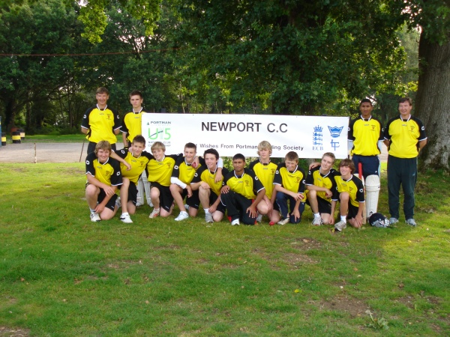
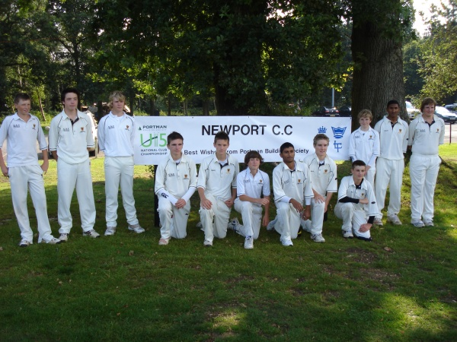
The Newport CC U15 Team - UK National Runners Up
The four Regional winners of England took part in the Finals Day:-
West of England Champions - Newport
South of England Champions - Tunbridge Wells (Kent)
North of England Champion - Mansfield Hosiery Mills (Nottinghamshire)
Midland Champions - Wem (Shropshire)

The format of the day saw the four competing teams take part in a Twenty 20, semi-final / final basis, with Newport being drawn to play Wem in their semi-final.

Semi Final: Newport v Wem (Shropshire)
Newport won the toss and put Wem into bat on a damp wicket. The move paid immediate dividends as spinner Imran Hassan (2-24) claimed two early wickets as Wem slipped to 12-2 off 4 overs. Just as Wem were recovering, left arm spinner Max Scarr made the breakthrough trapping M.Cohen LBW for12, making the score 32-3 off 8 overs. Chief run getter, A.Ollerenshaw was beginning to look dangerous although Tim Thomas quickly claimed a further wicket. Excelent fielding backed up tight bowling, particularly Josh Aston, who bowled his 4 overs for just 11 runs. Three run outs made life extremely difficult for Wem and when Ollerenshaw finally departed, another victim of Thomas (2-16), the writing was on the wall as Wem had fallen to 71-7 off 17 overs. The remaining batsmen were soon out, both victims to Najaf Iqbal (2-10), as Wem fell to 82 all out in the final over.
On a slow wicket, any thought of an easy victory soon disappeared, as Newport lost two wickets with just 19 runs on the board off 6 overs. When Imran Hassan departed for a useful 21, with the score on 35-3 off 10 overs, it was very much a game in the balance. However, an excellent controlled innings by Josh Aston, with useful support from Najaf Iqbal 12, and Max Scarr 8 not out began to give Newport the upper hand. With 18 required off three overs Aston, accelerated the Newport score at just the right time, and Newport passed the Wem total with 6 wickets and just 4 balls remaining. Aston finishing with an excellent 29 not out.
With Tunbridge Wells easily overcoming Mansfield in their Semi-Final the stage was set for a Newport - Tunbridge Wells Final.
Final: Newport v Tunbridge Wells (Kent)
Newport again won the toss and this time decided to bat first. Imran Hassan and fellow opener Tom Cleeve immediately set about the Tunbridge opening attack, with Hassan, celebrating his recent call up to the England U16 squad, in dominant mood. After 7 overs the Newport score was on 37-0, and with Hassan showing his true class, with a quality array of shots all around the ground, a large Newport total looked likely. From 59-0 off 10 overs, the Newport openers Hassan in particular, but well supported by Cleeve, began to score freely and completely dominate the Tunbridge attack. However, with the score on 80-0 off 12 overs, the game turned as Imran Hassan was forced to retire having scored fifty. Imran, whose innings included 6 fours, received a huge round of applause from the large crowd who had witnessed an exceptional, high quality innings. Just as Newport needed to accelerate they lost 3 quick wickets, including the wicket of Cleeve for 21, and suddenly fell to 86-3 of 15 overs. Najaf Iqbal 15, Rhyddian Knox 11, Max Scarr and James Baker all added quick runs in the final overs and Newport's innings finally closed on a useful 123-6.
In reply Tunbridge openers, C.Williams and T.Elliott, who had both scored fifties in their semi-final victory over Mansfield, were keen to get off to a quick start. However, when Max Scarr bowled Williams for 10 with the Tunbridge score on 12 off 2 overs, Newport had got off to a dream start. S.Stickler joined Elliott and the pair enjoyed their share of early luck, as two difficult chances were dropped and the ball squirted beyond the grasp of fielders on several occasions. However, having rode their luck, the two batsmen played very maturely gradually playing Tunbridge into a winning position. At 75-1 off 13 overs the game was finely balanced but Newport needed to break the partnership. Despite everything Newport tried it was not to be their day, there was a glimmer of hope when Stickler had to retire on 50, and then next ball fellow opener Elliott was out for 42, with the score on 112 off 17 overs. Had the stand been broken earlier it may have been a different story, but the remaining Tunbridge batsmen scrambled the winning runs with just 11 balls remaining.
Despite losing Newport can take great credit from the game. Having won the UK National Finals as U/13's and then progressing to the Final of the UK U15 National Finals is a tremendous achievement.

The Road to the UK Finals

Welsh Cup Win
Despite the atrocious weather, Newport Cricket Club's very talented U/15 team won the Portman U/15 Welsh Cup to become Welsh Champions for
the fourth consecutive year. Having won the tournament at U/13 level in 2004, they retained the Trophy on their way to becoming Under 13 UK Club
Champions in 2005. The talented young team won the Under 15 Welsh Cup in 2006 and have now retained it for a fourth consecutive year. At the
fourth attempt, following previous cancellations due to the recent heavy rain, Newport travelled to Northop Hall Cricket Club in North Wales to play
their counterparts from Gowerton and Northop. In the first game Newport were put in to bat on a wet wicket and needed all their resolve to
accumulate a useful 98-3 from their allotted 18 overs against North Wales champions Northop. Adam Millichip top scoring with 24 not out, being
ably supported by Josh Aston with 21. In reply Northop made a disastrous start slumping to 7–3, following impressive bowling by James Baker and
Imran Hassan. However, the strength of the North Walians was evident as J. Evans and D. Foulkes 30, set about rebuilding the Northop innings.
With the score on 83–4, and 3 overs remaining, victory was insight, but Newport opening bowlers Najaf Iqbal and James Baker had other ideas,
returning to the attack to demolish the middle order batting with 3 wickets apiece. At 90-7, and the last over to be bowled, the game was in the
balance, but a magnificent boundary catch by Baker to get rid of Evans for a very good 48 in the last over, allowed Newport to squeeze home by 3 runs.
Najaf Iqbal completing his spell with excellent figures of 3-14 and James baker finishing with 3-15.
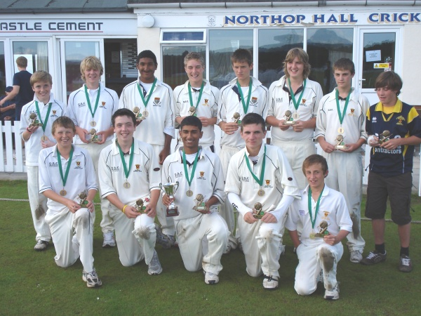
Newport CC U15 - Welsh Cup Winners 2007

Regional Finals at Bath
Having recently won the Welsh Cup and then defeating Gloucestershire Champions Thornbury, Newport Cricket Club's U/15 Team, who won the Under 13 UK National Finals two years ago, booked their place in this year's Under 15 UK National Finals, with two resounding wins against Cornish Champions, Newquay and Hampshire Champions, Basingstoke, in the South West of England Regional Finals Day, at Bath Cricket Club.
Newport v Newquay
Played on a Semi-Final / Final format, Newport's first match was against Newquay, with Newport electing to bat on winning the toss. Newport openers,
Imran Hassan, recently selected for the England U/15 team, and Tom Cleeve made a steady start putting on 46 for the first wicket in 8 overs before
Cleeve was out for 11. Adam Millichip joined Imran and gave good support as the score soon began to accelerate, with Imran (51) in total command.
Having reached his fifty he had to retire with the score on 96 off 15 overs. Millichip 18, Josh Aston, Najaf Iqbal, James Baker and Tim Thomas all made
useful contributions in quick time, taking the final Newport score up to an impressive 141-5 when their alloted 20 overs were completed.
Newport caught Newquay by surprise by opening the bowling with leg spinner, Imran Hassan and West of England, left arm spinner Max Scarr.
It was Scarr who claimed the first two wickets to fall, as Newquay slipped to 31-2 off 8 overs. J Hancock 28 offered stubborn resistance, but the
introduction of off spinner Josh Aston made further in raods into the Newquay batting line up. However it was medium pacer, Tim Thomas who
destroyed the Newquay middle order, claiming 4 wickets in just two overs. From 71-4 off 14 overs, he saw Newquay reduced to 79-8 in 16 overs b
efore eventually falling to 82 all out. Najaf and Elgan Alderman claiming the final two wickets, with Thomas finishing with remarkable figures of 4-9.
The other semi-final saw reigning U/15 UK Champions Parley, defeated by Basingstoke, who scored the winning runs in a tense, last over thriller.
Newport v Basingstoke
In the Final, Basingstoke put Newport in to bat, who were once again well served by openers Imran Hassan and Tom Cleeve, who laid a solid foundation scoring an opening partnership of 60 in 11 overs, before Cleeve was unluckily run out for 18. Imran took the game by the scruff of the neck, scoring freely to all parts of the ground in a superb innings of 53, before he once again had to retire, with the Newport score on 108-2 off 17 overs. Some excellent attacking stroke play by Josh Aston 24 not out, ably supported by Najaf Iqbal saw the Newport innings close on a good 130-2 off their 20 overs.Newport stuck to the ploy of opening the bowling with their spin attack, and got off to the best possible start as Imran had M.King trapped LBW to the first ball of the innings. G. McKenzie 21 and A. Rouse 16 led somewhat of a recovery to 42 off 7 overs, but when James Baker had Rouse well caught on the boundary by Tim Thomas, the game suddenly slipped away from Basingstoke. The dangerous McKenzie was immediately run out, by a direct hit from Cleeve, while Thomas continued his remarkable bowling display from the previous game claiming a further 3-13. Josh Aston claimed 2-8 as Basingstoke slumped to 68-6. R.Trevaskis offered token resistance with 19 not out, but it was all in vain as they were eventually bowled all out for 102 in the final over leaving Newport victorious by 28 runs.
Newport now progress to the National UK Finals Day held at Bournemouth Cricket Club on August 22nd. From a record entry of 1 704 teams, Newport will take their place as one of four teams who will now contest the trophy.

