Newport Cricket Club 1st X1 Captain: Gary Wood
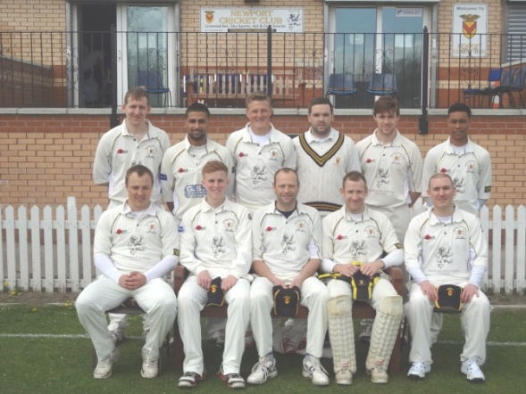
Results 2013
Date | Against | Venue | Type | Result
06/04/2013 | Pentyrch | Home | Friendly | Newport Won by 9 wkts | More...
13/04/2013 | UWIC | Home | Friendly | Cancelled | More...
20/04/2013 | Radyr | Home | Friendly | Newport won by 179 runs | More...
04/05/2013 | Mumbles | Home | SWPL | Losing Draw +30 | More...
11/05/2013 | Cardiff | Away | SWPL | Lost by 2 wkts (off last ball) | More...
18/05/2013 | Swansea | Home | SWPL | Won by 66 runs | More...
25/05/2013 | Port Talbot | Away | SWPL | Won by 5 wkts | More...
26/05/2013 | Ammanford | Away | SWPL T20 | Lost by 164 runs | More...
26/05/2013 | Ynysygerwn | Away | SWPL T20 | Won by 8 wkts | More...
01/06/2013 | Bridgend | Home | SWPL | Lost by 9 wkts | More...
08/06/2013 | Ammanford | Away | SWPL | Won by 5 wkts | More...
15/06/2013 | Ynysygerwn | Away | SWPL | Lost by 4 wkts | More...
22/06/2013 | Pontarddulais | Away | SWPL | Lost by 8 wkts | More...
29/06/2013 | Sully | Home | SWPL | Losing Draw +30 | More...
06/07/2013 | Mumbles | Away | SWPL | Lost by 4 wkts | More...
13/07/2013 | Cardiff | Home | SWPL | Won by 68 runs | More...
20/07/2013 | Swansea | Away | SWPL | Won by 7 wkts | More...
27/07/2013 | Port Talbot | Home | SWPL | Abandoned | More...
03/08/2013 | Bridgend | Away | SWPL | Winning Draw (within 9runs) | More...
10/08/2013 | Ammanford | Home | SWPL | Won by 2 wkts | More...
17/08/2013 | Ynysygerwn | Home | SWPL | Match Abandoned | More...
24/08/2013 | Pontarddulais | Home | SWPL | Lost by 6 wkts | More...
31/08/2013 | Sully | Away | SWPL | Won by 18 runs | More...

South Wales Premier League – Final Positions 2013
 | p | ltw | ltl | tbw | tbl | tfw | tfl | w9 | l9 | w19 | l19 | w29 | l29 | w30 | l30 | can | abn | lcn | wcn | t | BatP | BowlP | Pen | Pts*
Mumbles CC | 18 | 0 | 0 | 0 | 0 | 0 | 0 | 0 | 0 | 1 | 0 | 0 | 0 | 6 | 0 | 1 | 0 | 0 | 0 | 0 | 84 | 68 | 0 | 328
Ynysygerwn CC | 18 | 0 | 0 | 0 | 0 | 0 | 0 | 0 | 0 | 0 | 1 | 0 | 0 | 0 | 0 | 1 | 2 | 0 | 0 | 0 | 73 | 61 | 0 | 276
Pontarddulais CC | 18 | 0 | 0 | 0 | 0 | 0 | 0 | 0 | 1 | 0 | 0 | 0 | 0 | 3 | 0 | 1 | 0 | 0 | 0 | 1 | 56 | 59 | 0 | 223
Sully Centurions CC | 18 | 0 | 0 | 0 | 0 | 0 | 0 | 0 | 0 | 0 | 1 | 0 | 0 | 2 | 0 | 1 | 2 | 0 | 0 | 0 | 59 | 54 | 0 | 223
Newport CC, Wales | 18 | 0 | 0 | 0 | 0 | 0 | 0 | 1 | 0 | 0 | 0 | 0 | 0 | 0 | 2 | 0 | 2 | 0 | 0 | 0 | 54 | 59 | 0 | 213
Bridgend Town CC | 18 | 0 | 0 | 0 | 0 | 0 | 0 | 1 | 2 | 1 | 0 | 0 | 0 | 1 | 1 | 1 | 1 | 0 | 0 | 0 | 41 | 65 | 0 | 199
Swansea CC | 18 | 0 | 0 | 0 | 0 | 0 | 0 | 1 | 0 | 1 | 0 | 0 | 0 | 0 | 3 | 1 | 1 | 0 | 0 | 0 | 56 | 51 | 0 | 189
Port Talbot Town CC | 18 | 0 | 0 | 0 | 0 | 0 | 0 | 0 | 0 | 0 | 0 | 0 | 0 | 0 | 3 | 2 | 1 | 0 | 0 | 0 | 50 | 49 | 0 | 179
Cardiff CC | 18 | 0 | 0 | 0 | 0 | 0 | 0 | 0 | 1 | 0 | 1 | 0 | 0 | 0 | 2 | 1 | 2 | 0 | 0 | 0 | 38 | 65 | 0 | 173
Ammanford CC | 18 | 0 | 0 | 0 | 0 | 0 | 0 | 1 | 0 | 0 | 0 | 0 | 0 | 0 | 1 | 1 | 1 | 0 | 0 | 1 | 49 | 52 | 0 | 148

