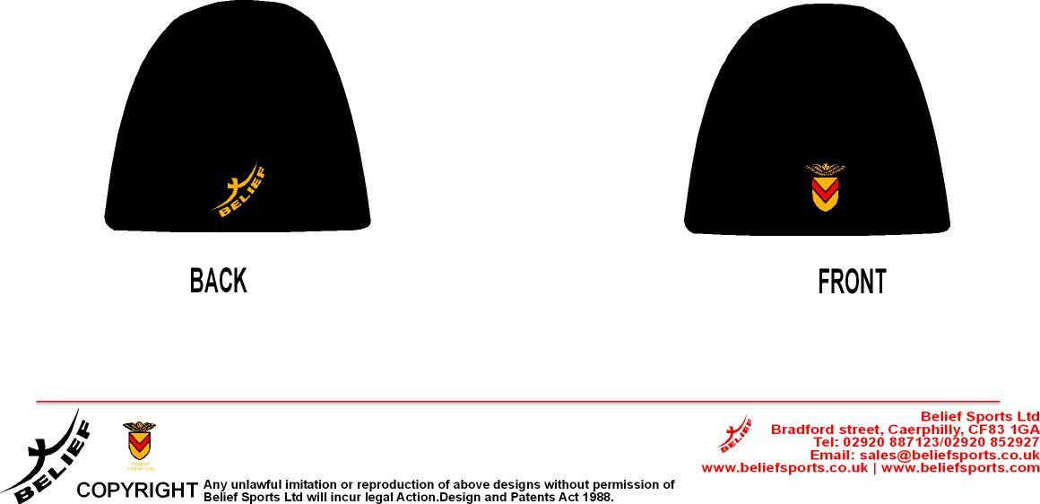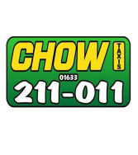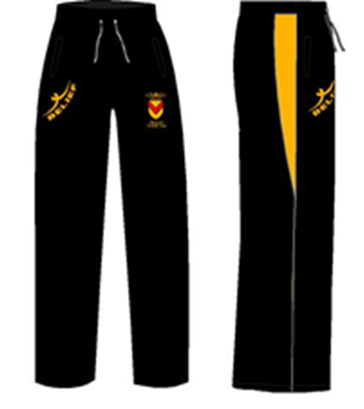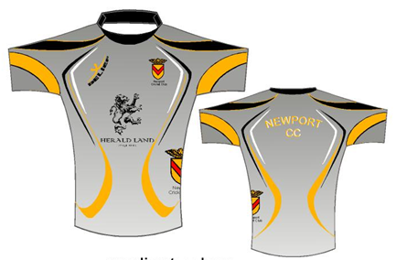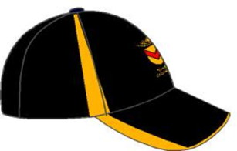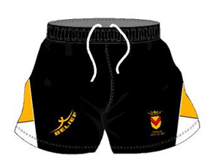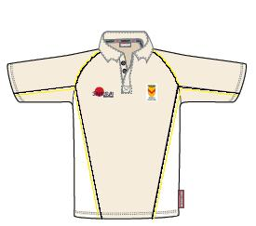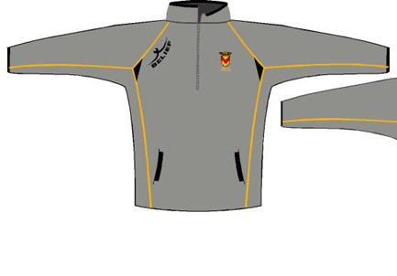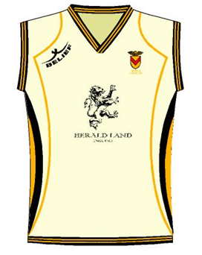

**Black Beanie Hat (New)**

**Dark Grey**

**Fleece**

**Coloured Trousers**

New

Sponsor

**CAP**

**TRAINING**

**SHORTS**

Nw

Sponsor

All Items Embroidered with Club Badge

Sponsor Logo on Shirt/Sweater/Training Tops

Newport CC on back of Training Tops

New

Sponsor

**SAMURAI CRICKET SHIRT**

**(as currently worn)**

***Any problems check with Mike***

**White Playing Sweater**

**TRAINING TOP**