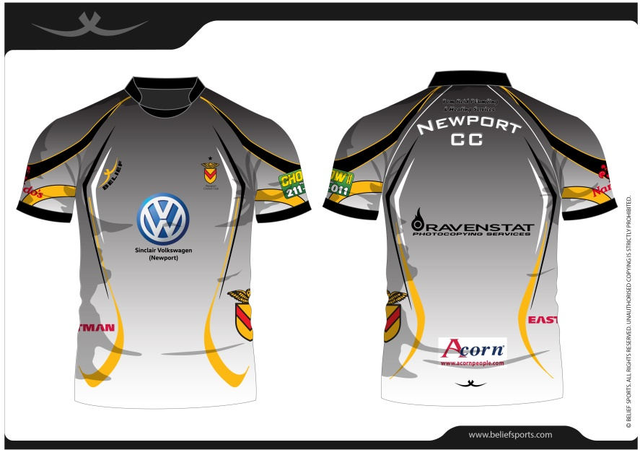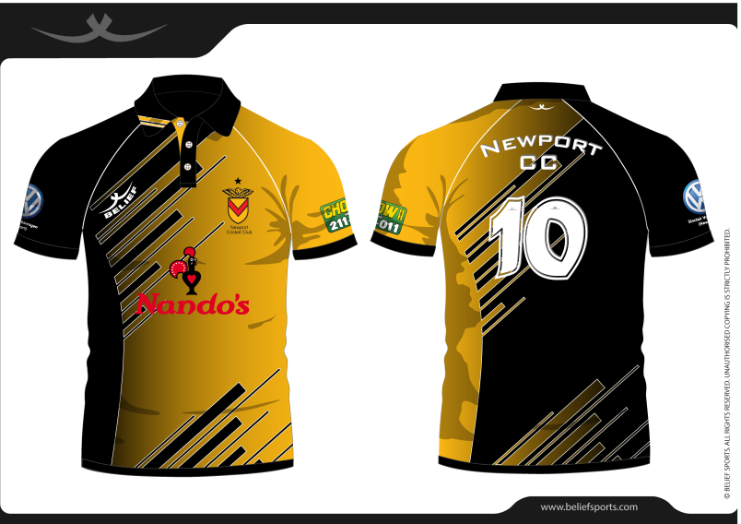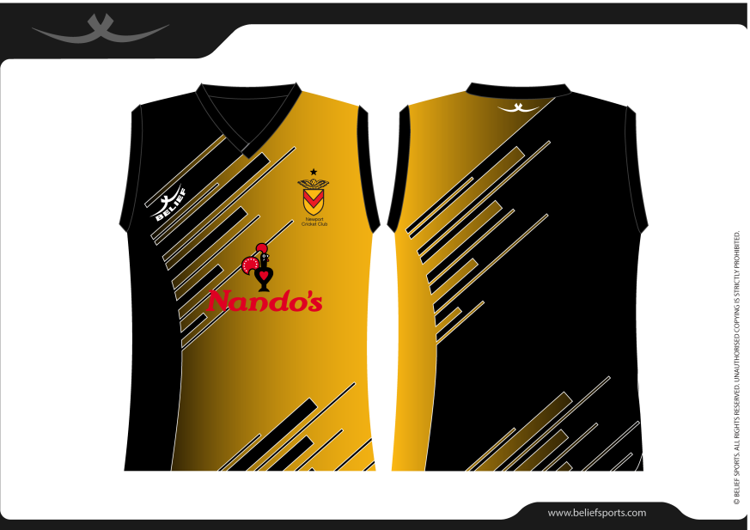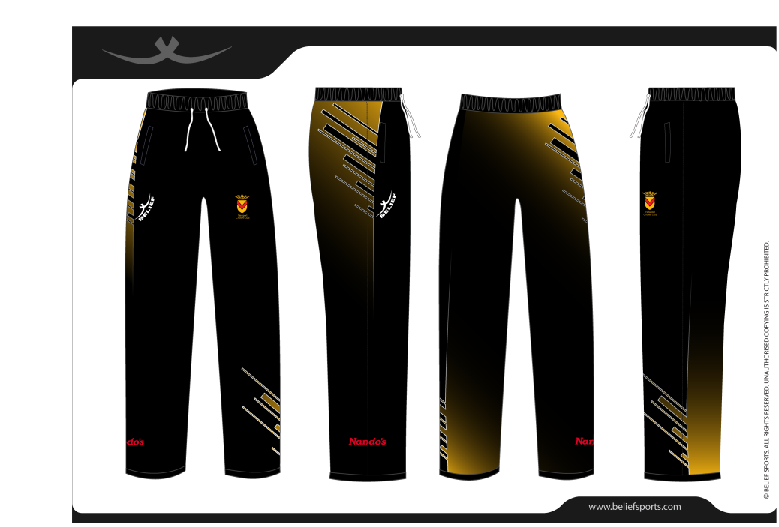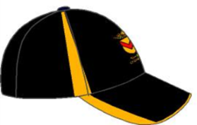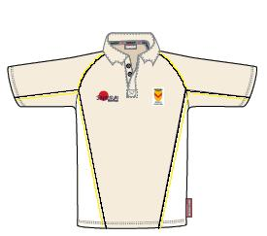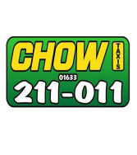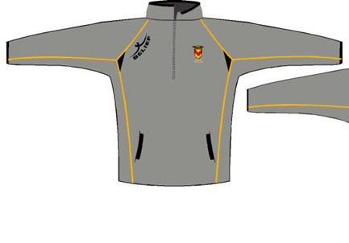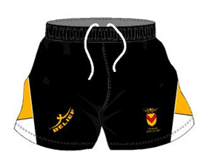

**Coloured Playing**

**Sweater (New 2018)**

**Coloured Cricket Shirt (New 2018)**

**Training Top**

**Trousers (New 2018)**

**SHORTS**

**CAP**

**Dark Grey Fleece**

**SPECIAL OFFER**

**Find a £250 Ground Advertising Banner Sponsor and get 50% off your new kit**

**See attached information sheet**

**SAMURAI CRICKET SHIRT**

**(as currently worn)**

***Any problems check with Mike***