Newport CC Win League & Cup Double
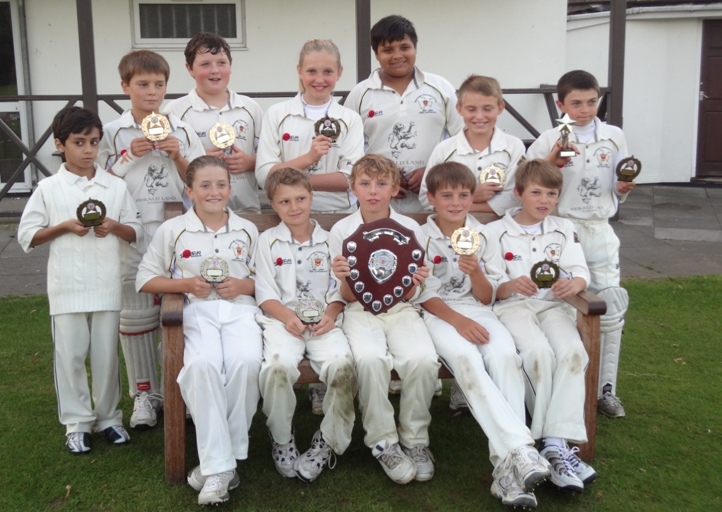
Newport Cricket Club U11's completed a League and Cup Double by beating Chepstow in this year’s Monmouthshire Youth Cricket Under 11 Cup Final at Sudbrook CC.

Chepstow batted first on winning the toss and got off to a solid start, but Newport captain and leg spinner, Will Smale bowled both openers to leave them on 32 for 2. George Bazley then took over control of the innings and looked to score runs. Wales captain, Smale organised the young Newport team superbly in the field, making it difficult for Bazley to cut loose. Unfortunately, only Ryan Scrivens managed to stay with him for any length of time scoring 16 runs. Tomos Evans took three wickets with Thomas Lynbeck, Thomas Protheroe and Charlotte Scarborough one apiece as wickets then fell steadily. Scarborough also took a fine catch as did Oscar Waters and Smale. Chepstow finished their 20 overs on 89 for 8 with Bazley undefeated on 40.
Newport got off to a fine start in reply with Smale(20) and fellow Welsh International Evans(32) putting on 52 for the first wicket. However, they had a slight wobble losing three wickets within ten runs of the winning total, as the Chepstow bowlers tightened the screw. Krishnan Hariharan however kept a cool head, contributed eleven valuable runs and the other batters chipped in to ensure victory by six wickets with an over to spare. Harry Pinchard and Louis Sacks took a wicket and Ryan Scrivens two.
The Player of the Match award, on the nomination of the umpires, was awarded to Tomos Evans for his match-winning bowling performance in taking three wickets and stop scoring with the bat on 32. This was a repeat of his achievement last year when Newport won the Under 11 title.
The win capped a fantastic season for the young Newport team, winning the League and Cup Double, and remaining unbeaten throughout the year.

