Newport CC U13’s Win League & Cup Double
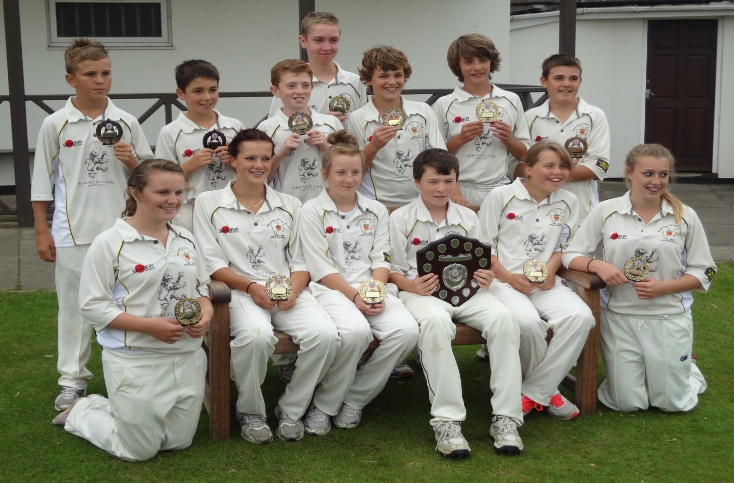
Newport Cricket Club U13’s won the 2012 Monmouthshire Building Society Under 13 Youth Cricket Shield Final, beating Sudbrook in the Final at Sudbrook

Newport were put into bat first on a damp wicket and lost regular wickets against Sudbrook with the first four batsmen clean bowled by Elliot Thomas (twice), Ben Supple and Michael Benjamin to leave them on 39 for 4 with only Ryan Ward (9) making any real contribution to the score. Thomas then took a catch off Rhys Sperring's bowling, Supple had another clean bowled and George Guppy and Dolan Rees combined to take the seventh wicket with the score on 61 before Ben Rose (10no) joined Georgia Parfitt (9no) to steady the ship and compose a fine 24-run partnership which took Newport to 85 for 7. This was a Jekyll and Hyde bowling performance by Sudbrook with some fine wicket-taking balls alongside others which led them to give away 38 extras. The pick of the bowlers were Supple with 2 wicket for 5 runs and Thomas with 2 for 11 in their four over spells.
In reply, the Sudbrook openers, Supple and Elliot Ferriman, were well on course for victory at 42 for 0 when Ward and Robbie Clarke were introduced to the attack. Ferriman (19) was caught by Izzie Berry off Ward who went on to bowl three more Sudbrook batters and Clarke also had two clean bowled. However, it was the wicket of Supple (24), deceived by Nicole Reid's leg-spin to be stumped by Joe Rabaiotti, that was to be the turning point of the game. The remaining batters couldn't keep up with the run-rate and, with another Rabaiotti dismissal off the bowling of Callum Stewart and a run-out, they finished eight runs short on 77 for 9. Ward's figures were 4 for 8 in four overs and Clarke took 2 for 12.
The Player of the Match award was given to Ryan Ward for his match-winning bowling performance in taking four wickets. The presentations were made by Glamorgan opening bowler Huw Waters who recalled his playing days in the competitition.

