Newport CC U15’s Win League & Cup Double
Newport Cricket Club U15 team continued their season’s successes with an emphatic 10 wicket victory against Croesyceiliog, in the Monmouthshire Building Society Youth Cricket Shield Under 15 Final at Sudbrook CC on Sunday.
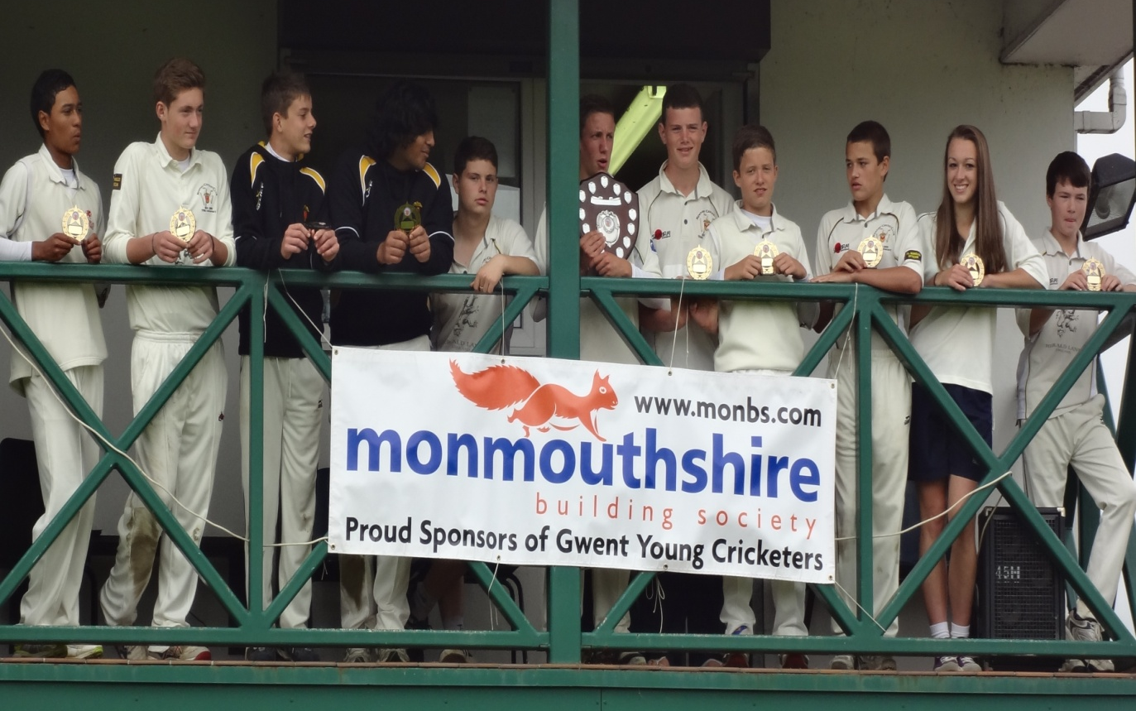

Having previously won the U15 Welsh Cup, followed by an outstanding run in the UK National competition, whereby they eventually lost to a very good Bath side in the final of the South West UK Regional Finals, Newport went into the game full of confidence.
Newport won the toss and asked Croesyceiliog to bat hoping to take advantage of the damp conditions typical of an early-September morning. This decision was soon justified with off-spinner, Scott Thornton removing the two openers, Luc Kear and Will Davey, one lbw and one caught by Luke Harris. With Luke Harris then bowling Jamie Norman, Croesyceiliog were on just four runs for the loss of three wickets. James Scarborough led the fightback but he was stumped by Rob Williams off the bowling of Darnell Taylor-Wood for sixteen and, thereafter, nobody got into double figures. Wickets then fell at regular intervals with a wicket falling to each of Thornton, Taylor-Wood and Ryan Ward. Ffion Wynne also bowled well conceding just tree runs in three overs. A good Newport fielding display saw Nathan Hariharan and Sion Edwards taking catches while Ryan Ward and Matt Jones effected run-outs. Croesyceiliog finished on 60 for 9 in their forty overs.
In reply, the Newport openers Jack Thorpe-Yon and Matt Jones reached the target comfortably in the twelfth over, scoring 24 and 28 respectively, ensuring Newport retained the trophy they had won last year. The win saw the Newport team to a League and Cup Double, having already won the U15 League.
The Player of the Match award was given, on the nomination of the umpires, to Scott Thornton for his match-winning bowling performance in taking the wickets of three of the top five batsmen for just four runs in four overs.

