Newport Cricket Club 2nd X1 SWPL Res.Div. League Champions
Captain: Phil MacLean
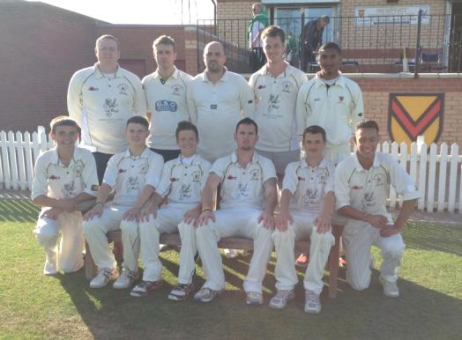
Results 2013
Date | Against | Venue | Type | Result
13/04/2013 | Machen | Home | Friendly | Cancelled | More...
04/05/2013 | Mumbles | Away | SWPL (Res. Div.) | Lost by 118 runs | More...
11/05/2013 | Cardiff | Home | SWPL (Res. Div.) | Cancelled | More...
18/05/2013 | Swansea | Away | SWPL (Res. Div.) | Lost by 1 wkt | More...
25/05/2013 | Port Talbot | Home | SWPL (Res. Div.) | Lost by 2 wkts | More...
01/06/2013 | Bridgend | Away | SWPL (Res. Div.) | Winning Draw (+30 runs) | More...
08/06/2013 | Ammanford | Home | SWPL (Res. Div.) | Winning Draw (within 29runs) | More...
22/06/2013 | Pontarddulais | Home | SWPL (Res. Div.) | Won by 130 runs | More...
23/06/2013 | Ynysygerwn | Home | SWPL (Res. Div.) | Won by 58 runs | More...
29/06/2013 | Sully | Away | SWPL (Res. Div.) | Won by 115 runs | More...
06/07/2013 | Mumbles | Home | SWPL (Res. Div.) | Won by 60 runs | More...
13/07/2013 | Cardiff | Away | SWPL (Res. Div.) | Won by 1 wkt | More...
20/07/2013 | Swansea | Home | SWPL (Res. Div.) | Won by 150 runs | More...
27/07/2013 | Port Talbot | Away | SWPL (Res. Div.) | Won by 82 runs | More...
03/08/2013 | Bridgend | Home | SWPL (Res. Div.) | Won by 7 wkts | More...
10/08/2013 | Ammanford | Away | SWPL (Res. Div.) | Winning Draw (+30 runs)
17/08/2013 | Ynysygerwn | Away | SWPL (Res. Div.) | Match Abandoned | More...
24/08/2013 | Pontarddulais | Away | SWPL (Res. Div.) | Won by 59 runs
31/08/2013 | Sully | Home | SWPL (Res. Div.) | Won by 9 wkts | More...
South Wales Premier League (Res. Div.) – Final Positions 2013
 | p | ltw | ltl | tbw | tbl | tfw | tfl | w9 | l9 | w19 | l19 | w29 | l29 | w30 | l30 | can | abn | lcn | wcn | t | BatP | BowlP | Pen | Pts*
Newport CC, Wales | 18 | 0 | 0 | 0 | 0 | 0 | 0 | 0 | 0 | 0 | 0 | 1 | 0 | 2 | 0 | 1 | 1 | 0 | 0 | 0 | 72 | 72 | 0 | 306
Pontarddulais CC | 18 | 0 | 0 | 0 | 0 | 0 | 0 | 1 | 1 | 0 | 0 | 0 | 0 | 3 | 1 | 0 | 1 | 0 | 0 | 0 | 70 | 59 | 0 | 282
Mumbles CC | 18 | 0 | 0 | 0 | 0 | 0 | 0 | 0 | 0 | 0 | 0 | 1 | 0 | 3 | 0 | 2 | 1 | 0 | 0 | 0 | 61 | 57 | 0 | 260
Ammanford CC | 18 | 0 | 0 | 0 | 0 | 0 | 0 | 0 | 0 | 0 | 0 | 0 | 1 | 0 | 2 | 2 | 1 | 0 | 0 | 0 | 63 | 57 | 0 | 233
Cardiff CC | 18 | 0 | 0 | 0 | 0 | 0 | 0 | 0 | 0 | 0 | 0 | 0 | 0 | 0 | 2 | 2 | 3 | 0 | 0 | 0 | 59 | 48 | 0 | 206
Bridgend Town CC | 18 | 0 | 0 | 0 | 0 | 0 | 0 | 0 | 0 | 0 | 0 | 0 | 0 | 1 | 1 | 0 | 2 | 0 | 0 | 0 | 57 | 55 | 0 | 204
Ynysygerwn CC | 18 | 0 | 0 | 0 | 0 | 0 | 0 | 1 | 0 | 0 | 0 | 0 | 1 | 1 | 0 | 1 | 1 | 0 | 0 | 0 | 59 | 51 | 0 | 201
Swansea CC | 18 | 0 | 0 | 0 | 0 | 0 | 0 | 0 | 0 | 0 | 0 | 0 | 0 | 1 | 0 | 2 | 1 | 0 | 0 | 0 | 50 | 48 | 0 | 180
Port Talbot Town CC | 18 | 0 | 0 | 0 | 0 | 0 | 0 | 0 | 1 | 0 | 0 | 0 | 0 | 1 | 1 | 1 | 0 | 0 | 0 | 0 | 52 | 48 | 0 | 177
Sully Centurions CC | 18 | 0 | 0 | 0 | 0 | 0 | 0 | 0 | 0 | 0 | 0 | 0 | 0 | 0 | 5 | 1 | 1 | 0 | 0 | 0 | 41 | 50 | 0 | 118

