Newport’s Girl Cricketers complete a unique UK ‘Winners Double’
Fresh from the Newport U13 Girls Lady Taverners UK Cup success, the Club’s U15 Girls team travelled to Leamington Cricket Club in buoyant mood for the U15 UK Finals. The girls were not to be denied and completed a remarkable UK ‘Winners Double’, beating Walmley (Midlands) and Ansty (Sussex) at the National Finals Day.
Four Regional winners throughout England and Wales had qualified through to the National Finals Day:- Walmley (Midland Regional Winners) Wrenthorpe (Northern Regional Winners) Ansty (South East Regional Winners) Newport (South West Regional Winners)
In their semi-final Newport were drawn to play last year’s winners Walmley. In an eagerly awaited clash between last season’s finalists, Newport were put into bat and made a solid start with openers Georgia Parfitt and Rose Evans scoring 45, before Parfitt was out for 18. Rose Evans batted throughout the innings, hitting a four off the last ball of the innings to reach her personal fifty and a Newport total of 113-4 from their allotted 20 overs. In reply, Walmley made a steady start reaching 17 before the loss of their first wicket. However, in a devastating spell of bowling Charlotte Scarborough ripped through the top order Walmley batting recording figures of 5 overs, 1 maiden, 3 wickets for 9 runs, to leave Walmley reeling at 25-3. An excellent run out by Ella Reed and a further wicket by Meg Simkins added to the Walmley woes and they could only reach 68-5, to leave Newport winners by 45 runs.
In the UK Final Newport played Ansty (Sussex), who had beaten Wrenthorpe (Yorkshire) in the other semi final. Newport were once again put in to bat and got off to a great start scoring 49, before Rose Evans was out for 22. Georgia Parfitt was joined by Ella Reed and the pair soon began to dominate the Ansty bowling sharing a match winning partnership of 96, to post a fantastic 145-1 Newport total. Reed made 28 not out, but Parfitt’s 70 not out was the highlight of the innings, scoring runs to all parts of the ground. Ansty were under tremendous pressure and when Charlotte Scarborough trapped opening batsman Lucy Western LBW for 0 with the third ball the writing was on the wall. Excellent bowling by Scarborough and Jess Thornton, who each took 3 wickets completely destroyed the Ansty batting and the Sussex team were all out for 28 in just 14.1 overs, to leave Newport winners by 117 runs.
Newport U15 Team : Rose Evans (Capt), Georgia Parfitt, Thea Huckle, Ella Reed, Charlotte Scarborough, Meg Simkins, Jess Thornton, Aimee Watson, Amy Harris, Sophie Osborn.
Having won both the U13 and U15 Lady Taverners UK titles, Newport have become the first Club to win the two prestigious UK age group titles in the same year. Head Coach Mike Knight praised the two teams saying, ‘To win one UK title was fantastic, but to become UK Champions at both age groups was incredible. The girls have worked hard in training since October and have been rewarded for their fantastic work ethic by becoming ‘Double UK Champions’. Everyone at the Club is very proud of them’
Any girls (aged 7-13 years) interested in learning to play cricket should contact Mike Knight (07793823294) or (mike.knight2@ntlworld.com for information about winter coaching.

Newport U15 Girls Lady Taverners UK Champions (2014)
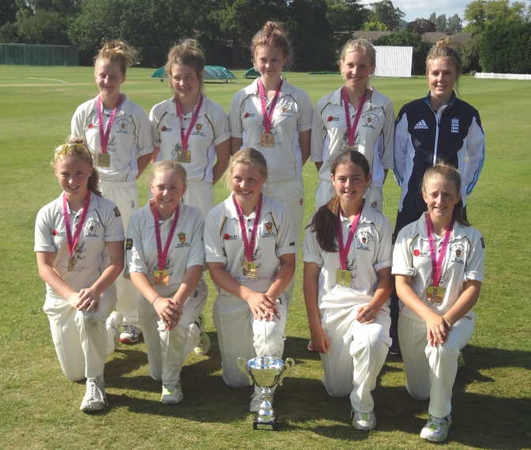

Team (Back L-R) : Georgia Parfitt, Meg Simkins, Thea Huckle, Charlotte Scarborough, Becky Grundy (England Women).
(Front L–R) : Aimee Watson, Amy Harris, Rose Evans (Capt), Ella Reed, Jess Thornton. Absent Sophie Osborn.

