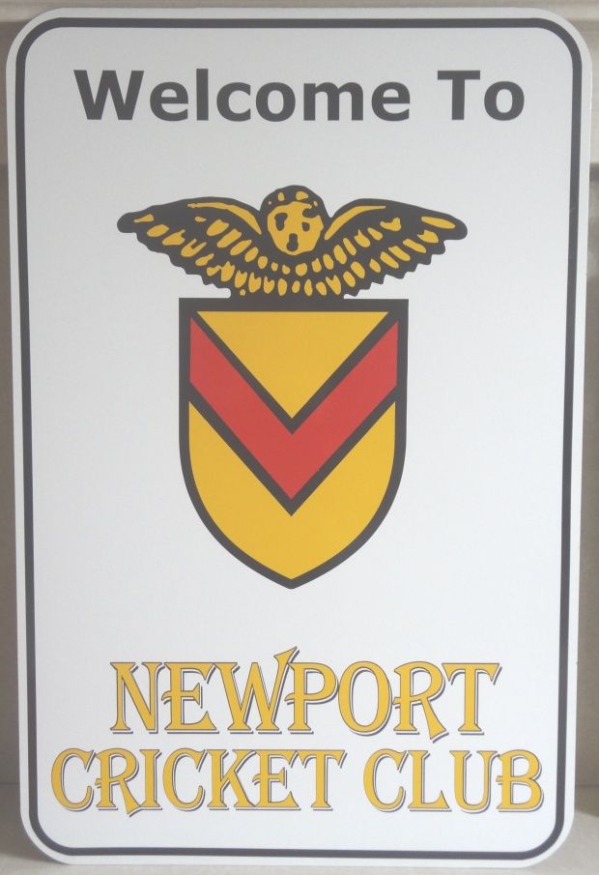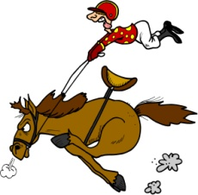

On

**SATURDAY, 3RD MARCH**

**1ST RACE IS 7.30PM**

PLEASE SUPPORT YOUR CLUB AND COME AND JOIN US FOR A NIGHT THAT IS GUARANTEED TO BE FUN AND RAISE MONEY TO HELP YOUR CLUB PROSPER.

TALLY HO!!

**OPTIONAL DRESS CODE** DRESS FOR A DAY AT THE RACES!

**HORSES ON SALE FOR £5 FROM THE SOCIAL COMMITTEE** – MIKE w, PAUL m, ADRIAN m, PHIL m, KEVIN b, VANESSA b OR DAVE OR MIKE KNIGHT

**FREE ENTRY. FREE ENTRY**

BET ON EACH RACE OR IF YOU FANCY, YOU CAN BUY A HORSE FOR £5 PER RACE TO INCREASE YOUR WINNINGS!

To be held at

**Newport cricket clubhouse**

Presents

**Race Nite**